HR People Analytics
Attrition Drivers & Pay Equity — Findings & Recommendations
Executive Summary
This analysis applied statistical significance testing — not just descriptive percentages — to 389 employees across 6 departments, to separate real attrition drivers from noise, and ran a gender pay equity check alongside it. Three factors are statistically confirmed attrition drivers: job satisfaction, distance from home, and lack of promotion among tenured staff. Separately, a gender pay gap was found to be statistically significant in 7 of 12 roles, always in the same direction.
Key Findings: Attrition
- Overall attrition rate: 33.2%, highest in Finance (46.6%) and Customer Support (37.5%), lowest in Operations (24.3%).
- Job satisfaction is a statistically significant driver (p=0.017) — employees who left averaged 3.13/5 satisfaction vs 3.45/5 for those who stayed.
- Distance from home is statistically significant (p=0.006) — employees who left commuted 24.6km on average vs 20.8km for those who stayed.
- Lack of promotion among employees with 3+ years' tenure is statistically significant (p=0.042) — this group leaves at a meaningfully higher rate than promoted peers with similar tenure.
- OverTime alone was not statistically significant on its own (p=0.316), but it appears as a real contributing factor once combined with other variables in the predictive model — a reminder that a single bivariate test can miss a factor that still matters in combination with others.
- A predictive model (logistic regression, AUC 0.678) ranks job satisfaction, work-life balance, and distance from home as the three strongest predictors of who leaves next.
Attrition Rate by Department
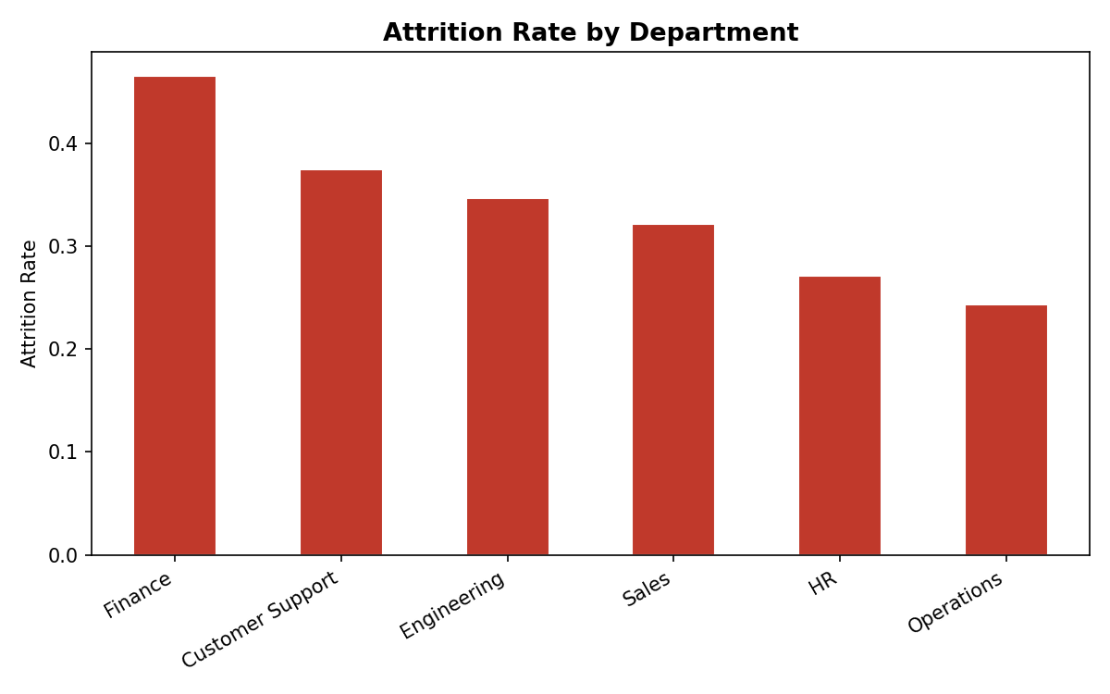
Key Findings: Pay Equity
- Company-wide, men earn 6.3% more than women on average across all roles pooled.
- This gap is statistically significant (p<0.05) in 7 of the 12 job roles — including Software Engineer (9.0% gap, p=0.002) and Sales Rep (8.7% gap, p=0.009) — meaning it is very unlikely to be due to chance in those roles specifically.
- The gap runs in the same direction in all 12 roles with no exceptions — this pattern, not any single role's number, is the strongest evidence of a systemic rather than incidental issue.
Gender Pay Gap by Role
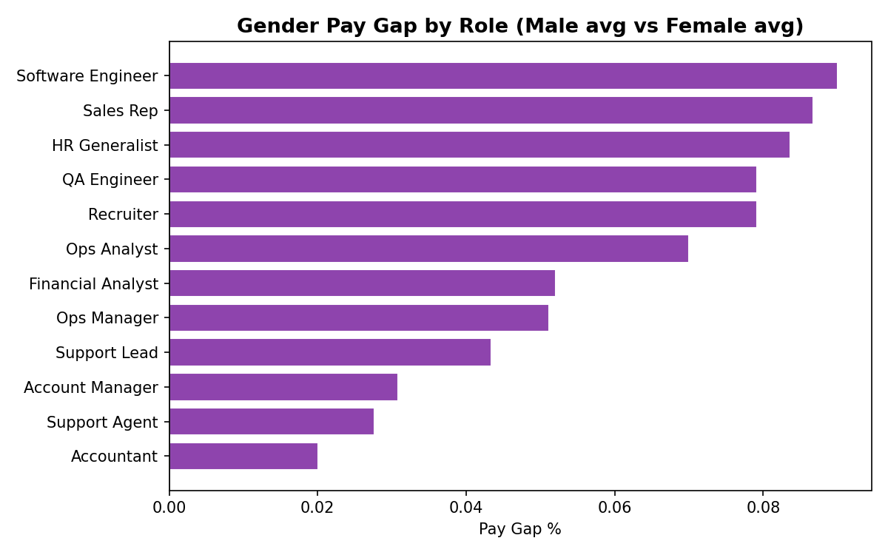
Top Current Employees by Predicted Attrition Risk
Ranked by the model's predicted probability of leaving — current, still-employed staff worth a proactive retention conversation, not a reaction after resignation.
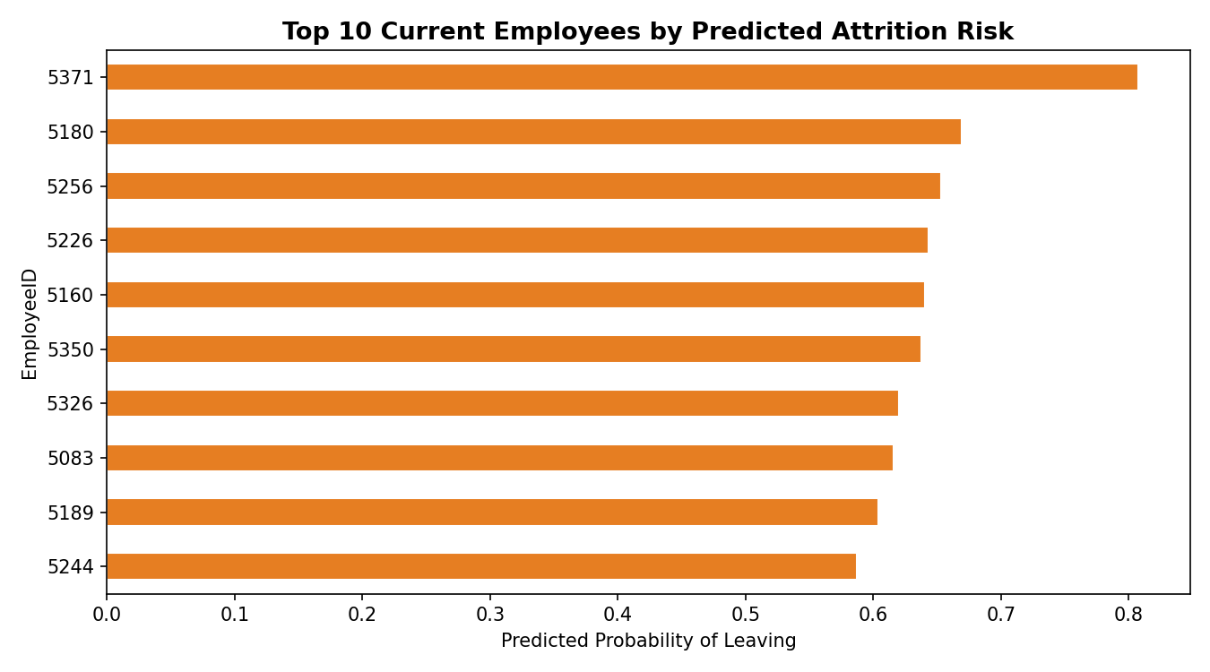
Recommendations
- Open retention conversations with the top 5 highest-risk current employees this month — several combine low job satisfaction with long tenure, meaning they're both valuable and close to leaving.
- Review promotion timelines for employees at 3+ years without advancement — this is a statistically confirmed, directly addressable driver, not a soft guess.
- Investigate the 7 roles with statistically significant pay gaps as a compensation equity review priority, starting with Software Engineer and Sales Rep given both the gap size and statistical confidence.
- For remote-eligible roles, consider flexible/hybrid arrangements for employees with long commutes — distance from home is a confirmed, and often addressable, attrition driver.
- Re-run both the attrition model and the pay equity check quarterly — an AUC of 0.678 and p-values based on one year of data will sharpen as more data accumulates, and a compensation review should not be a one-time event.
Methodology Note (for technical review)
Data stored in SQL Server (PeopleAnalytics database — see 01_schema.sql). Statistical testing in Python (scipy): chi-square tests for categorical drivers (OverTime, Promotion), independent t-tests for continuous drivers (Job Satisfaction, Distance From Home) and the pay equity check per role. Predictive model: logistic regression (scikit-learn) on standardized features, evaluated via train/test split and AUC-ROC. Power BI dashboard connects to the same SQL Server database with a drill-through page from department-level summary to individual employee detail — see the README for the build guide.

